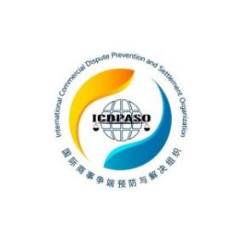
INTERNATIONAL COMMERCIAL DISPUTE PREVENTION AND SETTLEMENT ORGANIZATION (ICDPASO)

MEMBERSHIP APPLICATION FORM

Applicant Name:

would like to comply with ICDPASO’s Charter and join the ICDPASO as a new group member, and hereby declares that the information provided is true and valid.

Applicant Information
Name of organization
Country
Address
Website
Legal Representative Information
Full Name
Nationality
ID Type & Number
Liaison Information
Full Name
Address
Phone Number
Wechat ID
E-Mail Address
Signature of Legal Representative

or Official Seal (Seal/Stamp):

Date:

*Please attach the LOGO of the applicant organization, a copy of the certificate of registration, the resumes and photos of the legal representative and contact person separately.

